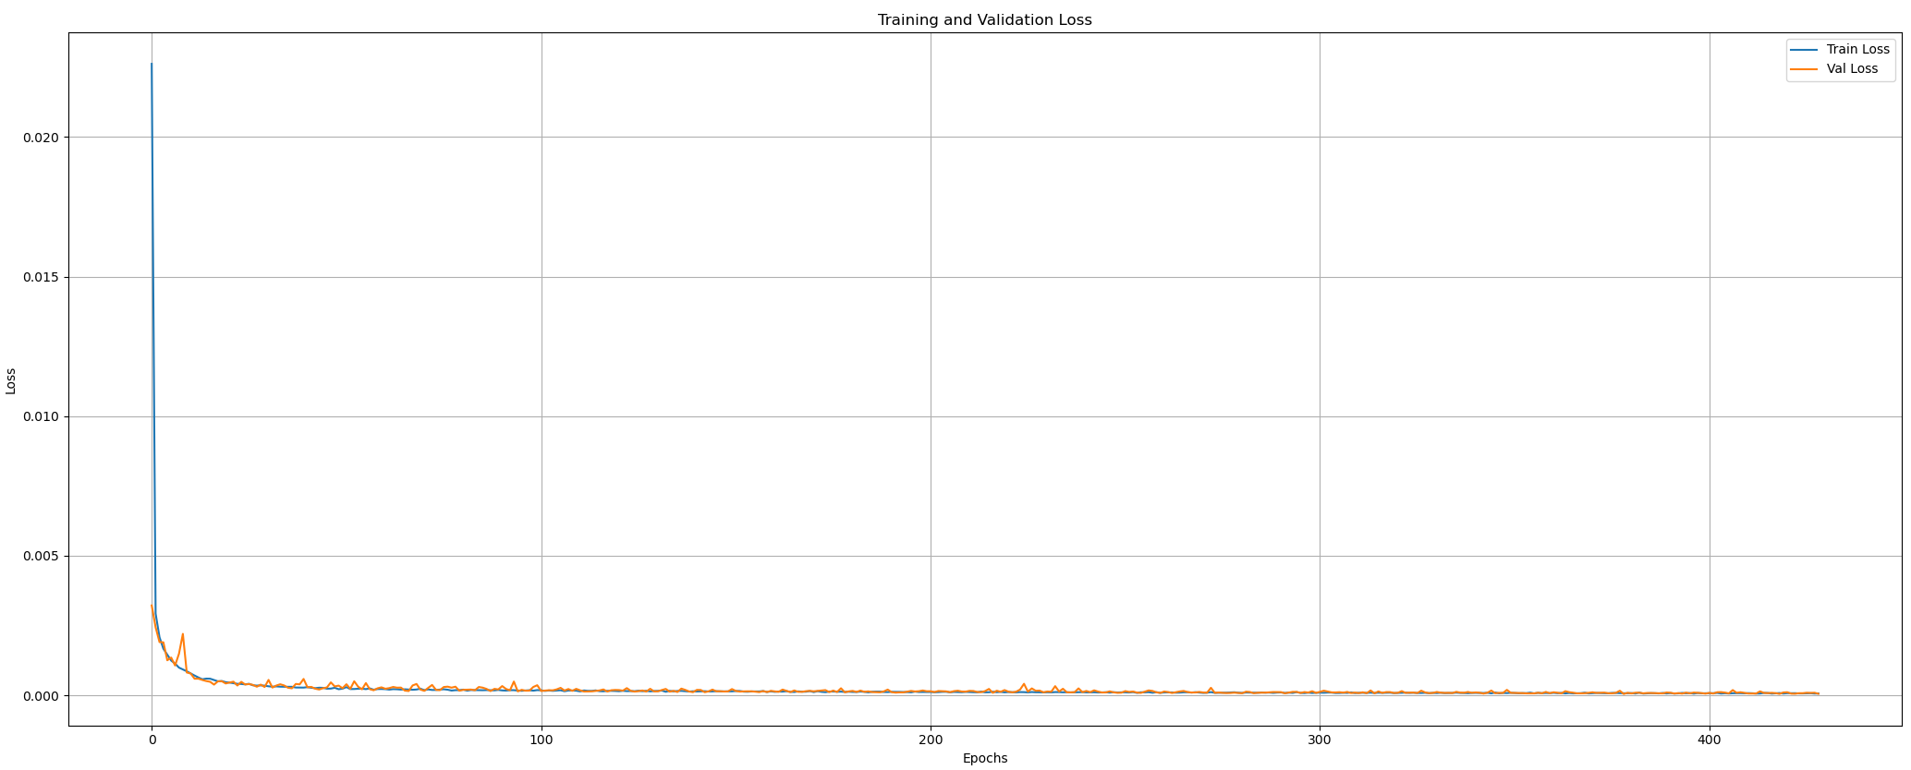

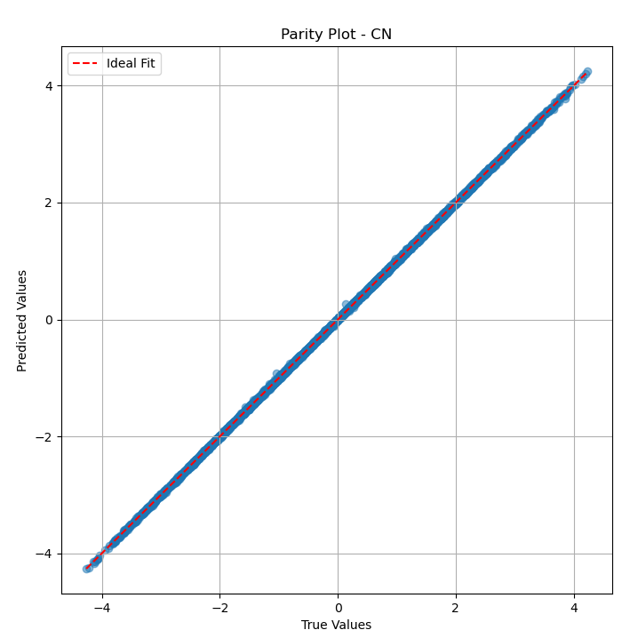

Output: CN | Test MSE: 0.0001, MAE: 0.0090, R^2: 0.9999

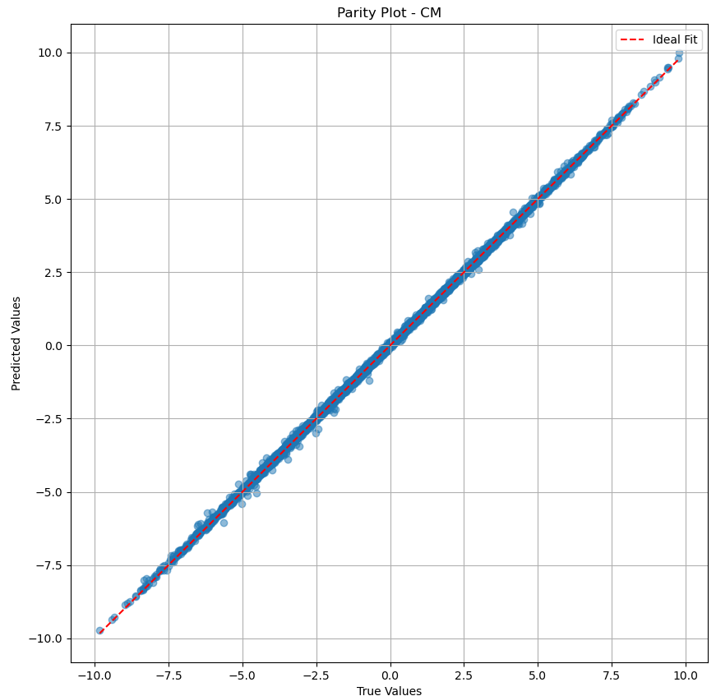

Output: CM | Test MSE: 0.0041, MAE: 0.0451, R^2: 0.9996

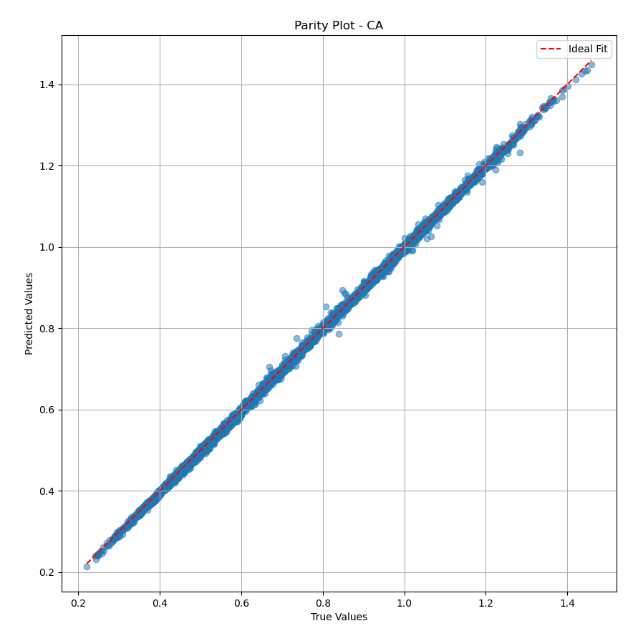

Output: CA | Test MSE: 0.0000, MAE: 0.0047, R^2: 0.9994

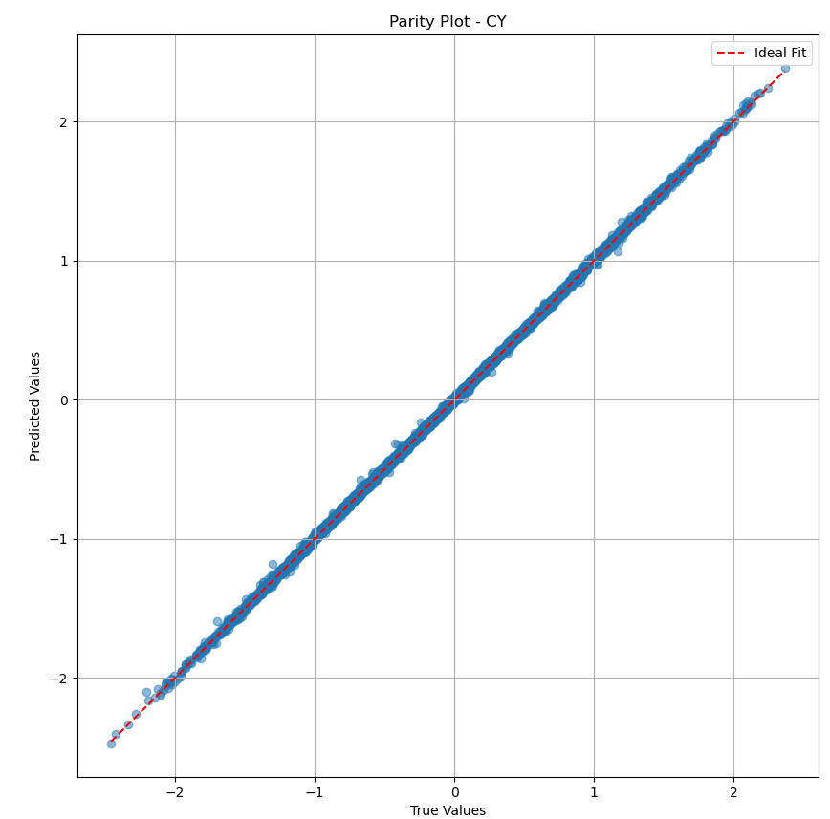

Output: CY | Test MSE: 0.0002, MAE: 0.0103, R^2: 0.9997

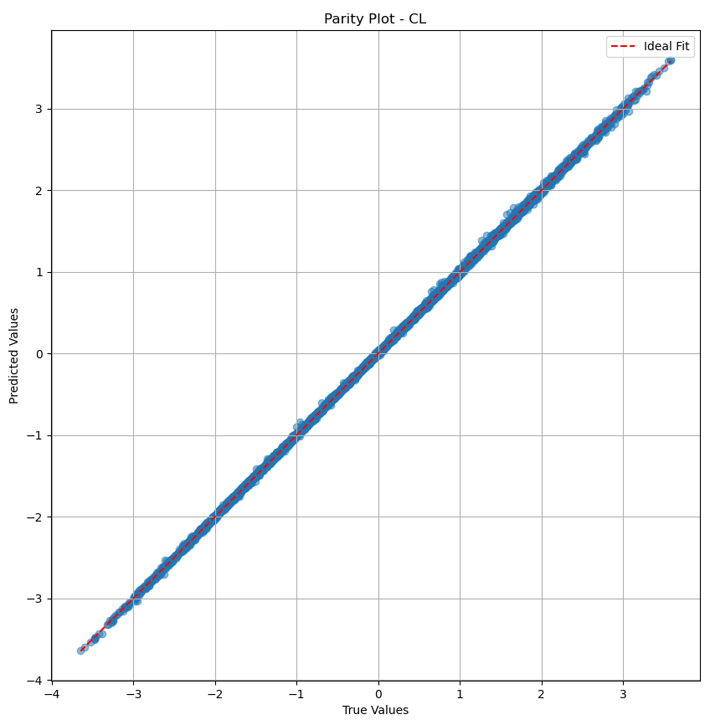

Output: CL | Test MSE: 0.0003, MAE: 0.0136, R^2: 0.9998

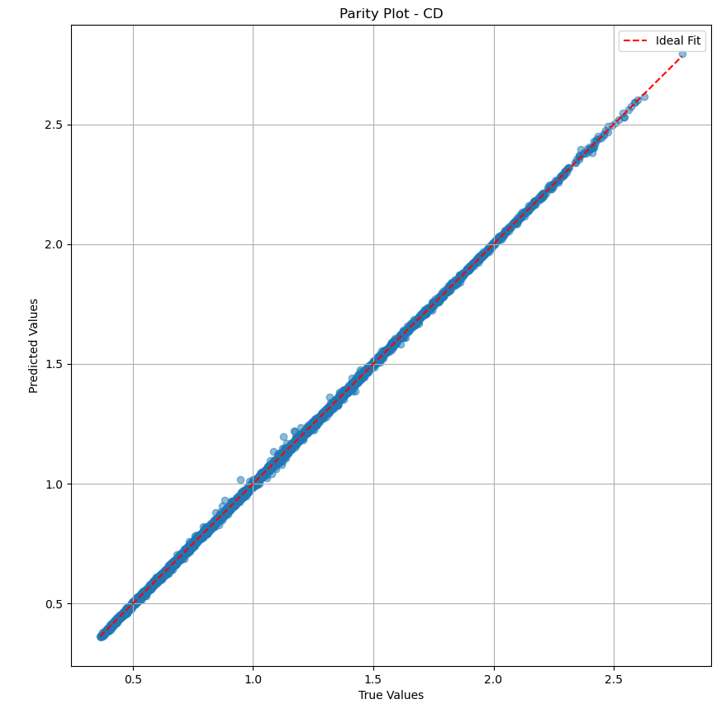

Output: CD | Test MSE: 0.0000, MAE: 0.0051, R^2: 0.9998

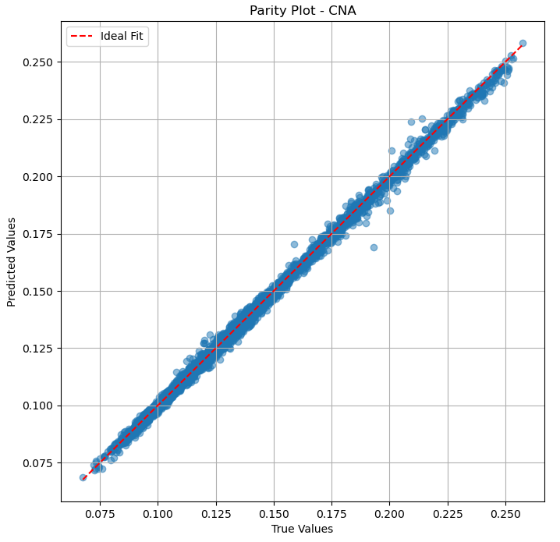

Output: CNA | Test MSE: 0.0000, MAE: 0.0012, R^2: 0.9978

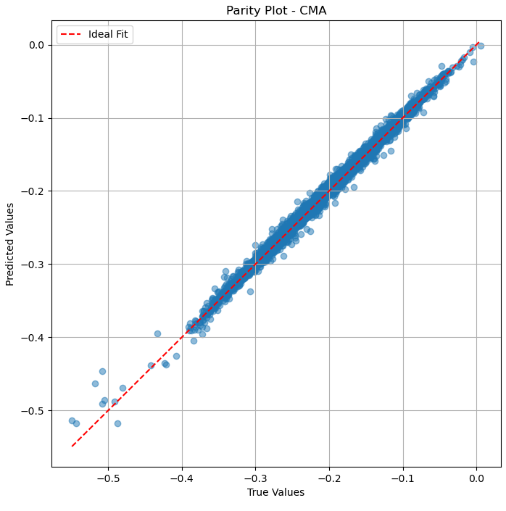

Output: CMA | Test MSE: 0.0000, MAE: 0.0040, R^2: 0.9935

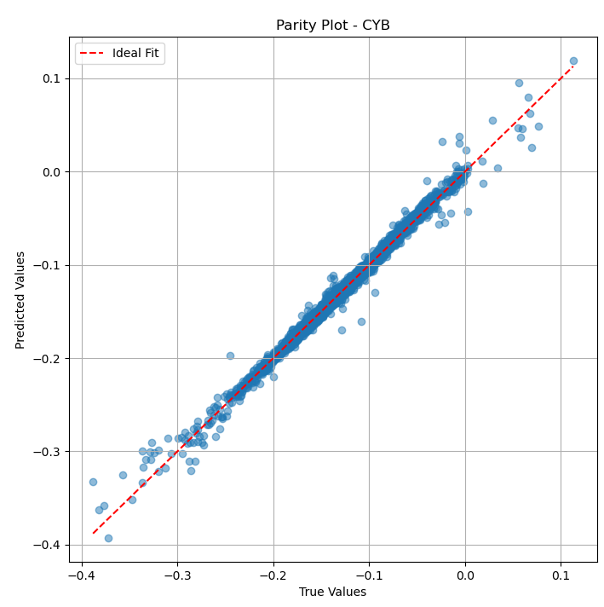

Output: CYB | Test MSE: 0.0000, MAE: 0.0027, R^2: 0.9905

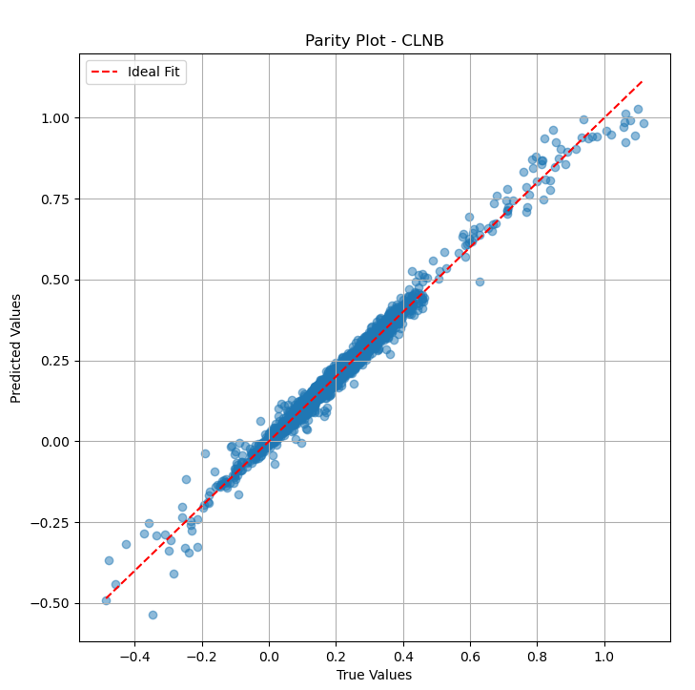

Output: CLNB | Test MSE: 0.0003, MAE: 0.0109, R^2: 0.9834